IFRA COMPLIANCE CERTIFICATE

PRODUCT NAME: Pomelo Sunrise

We certify that the above compound is in compliance with the Standards of the International Fragrance Association (IFRA) 50th Amendment (published June, 2021), provided it is used in the following IFRA Classes at a maximum concentration level of:
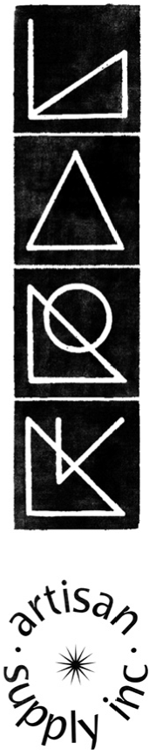

◆

CATEGORY | DESCRIPTION | LIMIT
1 | Products applied to the Lips and Toys | Not Approved
2 | Products applied to Axillae/underarm | 11.51%
3 | Products applied to the face/body using fingertips | 2.59%
4 | Products related to fine fragrance and applied to neck, face, and wrists | 49.22%
5A | Body products applied to the body using the hands/palms, primarily leave-on | 25.99%
5B | Face products applied to the face using the hands/palms, primarily leave-on | 2.15%
5C | Hand products applied to the hands using the hands/palms, primarily leave-on | 5.13%
5D | Baby creams, oils, and baby talc | 0.71%
6 | Oral Care products with oral and lip exposure | Not Approved
7A | Hair Chemical Treatments - Rinse-off products applied to the hair with some hand contact | 4.20%
7B | Hair Treatments and Styling Aids - Leave-on products applied to the hair with some hand contact | 4.20%
8 | Products with significant anogenital exposure | 0.71%
9 | Rinse Off Hair/Body/Face products with body and hand exposure | 9.99%
10A | Household care products excluding aerosol products | 9.99%
10B | Household and Air Care aerosol/spray products | 41.33%
11A | Products with intended skin contact but minimal transfer of fragrance to skin from inert substrate without UV exposure | 0.71%
11B | Products with intended skin contact but minimal transfer of fragrance to skin from inert substrate with potential UV exposure | 0.71%
12 | Products not intended for direct skin contact, minimal or insignificant transfer to skin | Not Limited

PLEASE NOTE:
For use in other applications or use at higher concentration levels, a new safety evaluation may be needed. Please contact us.

The IFRA Standards regarding use restrictions are based on safety assessments by the Panel of Experts of the Research Institute for Fragrance Materials (RIFM) and are enforced by the IFRA Scientific Committee.

Evaluation of individual fragrance ingredients is made according to the safety standards contained in the relevant section of the IFRA Code of Practice. It is the ultimate responsibility of our customer to ensure the safety of the final product (containing the fragrance) by further testing if needed.
Lark Artisan Supply Inc. hello@larksupply.ca (250) 701-6506

